**HIVE MINI PROJECT -1 SOLUTION**

1. Create a schema based on the given dataset

By considering the data type for date and timestamp as string, data in both tables have been loaded.

Later, by using below syntax and creating new table date format has been changed to standard date format.

a) FROM UNIX_TIME(UNIX_TIMESTAMP (date, ‘dd-MMM-yy’), ‘yyyy-MM-dd’) – For agent_login_report.

b) FROM UNIX_TIME(UNIX_TIMESTAMP (date, ‘MM-dd-yyyy’), ‘yyyy-MM-dd’) – For agent_performance

2. Dump the data inside the hdfs in the given schema location.

Both tables loaded on HDFS location.

hdfs://quickstart.cloudera:8020/user/hive/warehouse/ineuron.db/agent_login_report hdfs://quickstart.cloudera:8020/user/hive/warehouse/ineuron.db/agent_performance

3. List of all agents' names.

Aditya Shinde

Aditya_iot

Amersh

Ameya Jain

Ankitjha

Anurag Tiwari

Aravind

Ayushi Mishra

Bharath

Boktiar Ahmed Bappy

Chaitra K Hiremath

Deepranjan Gupta

Dibyanshu

Harikrishnan Shaji

Hrisikesh Neogi

Hyder Abbas

Ineuron Intelligence

Ishawant Kumar

Jawala Prakash

Jaydeep Dixit

Khushboo Priya

Madhulika G

Mahesh Sarade

Maitry

Manjunatha A

Mithun S

Mukesh

Muskan Garg

Nandani Gupta

Nishtha Jain

Nitin M

Prabir Kumar Satapathy

Prateek _iot

Prerna Singh

Rishav Dash

Saikumarreddy N

Sanjeev Kumar

Saurabh Shukla

Shiva Srivastava

Shivan K

Shivananda Sonwane

Shubham Sharma

Sowmiya Sivakumar

Sudhanshu Kumar

Suraj S Bilgi

Swati

Tarun

Wasim

Zeeshan

4. Find out agent average rating.

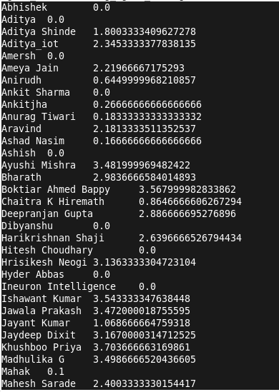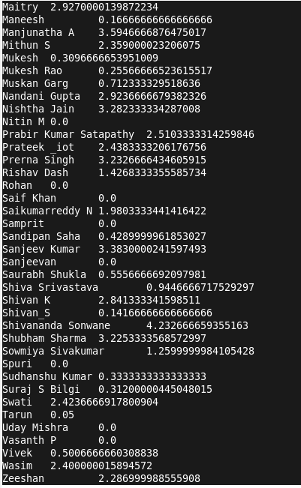

5. Total working days for each agents.

select agent_name, count(DISTINCT date_col) AS total_working_days from agent_login_report group by agent_name;

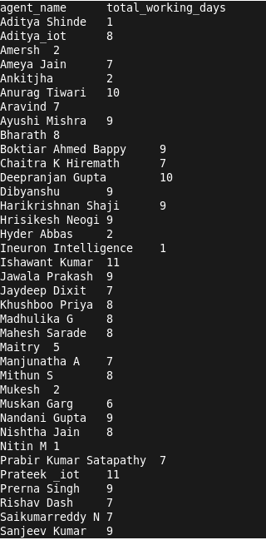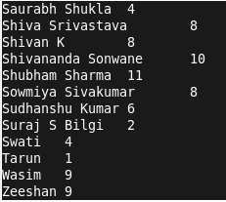

6. Total query that each agent have taken

select agent_name, sum(total_chats) as total_query from agent_performance group by agent_name;

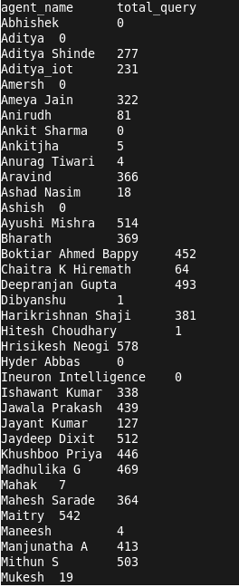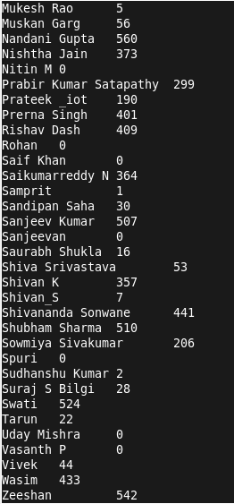

7. Total Feedback that each agent have received

select agent_name, sum(total_feedback) AS total_feedback_each_agent from agent_performance group by agent_name;

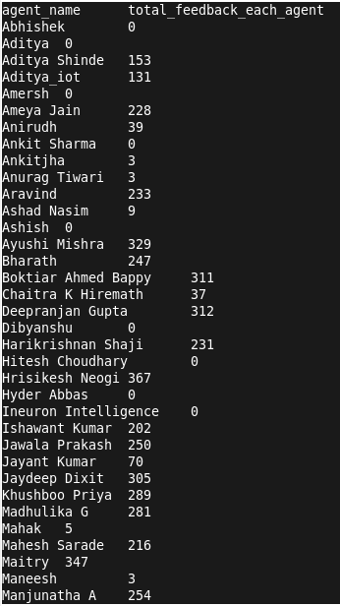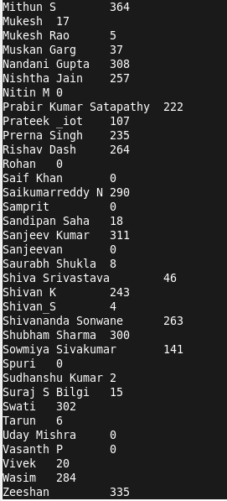

8. Agent name who have average rating between 3.5 to 4

select agent_name, avg_rating from agent_performance where avg_rating between 3.5 and 4;

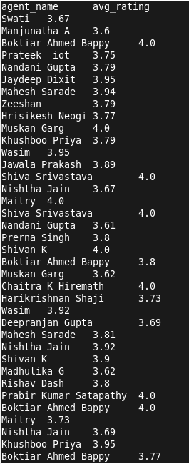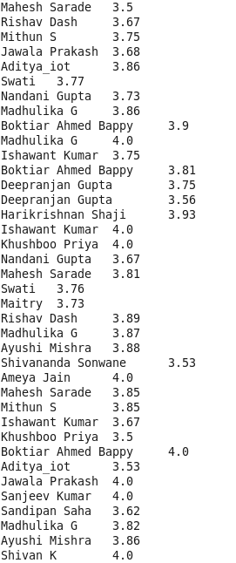

9. Agent name who have rating less than 3.5

select agent_name, avg_rating from agent_performance where avg_rating < 3.5;

Total 1474 records received as a result who have rating less than 3.5.

10. Agent name who have rating more than 4.5

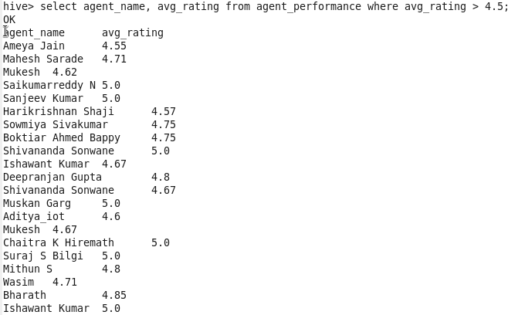

11. How many feedback agents have received more than 4.5 average

select agent_name,avg(total_feedback)from agent_performance group by agent_name having avg(total_feedback)>4.5;

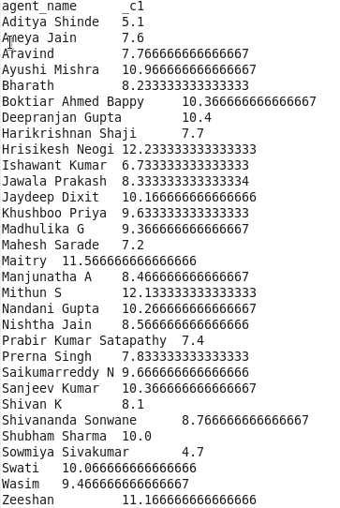

12. average weekly response time for each agent